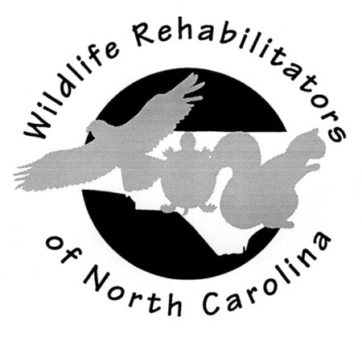
NEWSLETTER FOR WILDLIFE REHABILITATORS OF NORTH CAROLINA
Volume 20 June 2005
A quarterly newsletter produced by the Wildlife Rehabilitators of North Carolina (WRNC). WRNC’s mission is to share information and knowledge about wildlife rehabilitation for the benefit of native wildlife. For comments or questions, write to: WRNC, 2542 Weymoth Rd, Winston-Salem, NC 27103.

Continuing Education

- Our fourth WRNC Symposium will take place Jan. 27-29, 2006 in Asheboro, North Carolina.

- Like to travel? IWRC upcoming classes and locations:

Date | Course | Location
Jul 09, 2005 - Jul 10, 2005 | 1AB: Basic Wildlife Rehabilitation | Dallas, TX
Oct 08, 2005 - Oct 09, 2005 | 1AB: Basic Wildlife Rehabilitation | Kingston, RI
Nov 08, 2005 - Nov 09, 2005 | 1AB: Basic Wildlife Rehabilitation | Toronto, ON CANADA
Nov 08, 2005 | 4BB: Initial Wildlife Care | Toronto, ON CANADA
Nov 09, 2005 | 3BB: Wildlife Feeding and Nutrition | Toronto, ON CANADA

For updated calendar, course information and registration go to: http://www.iwrc-online.org/training/training.cfm

- The WRNC website maintains a training information page with contact details. Check it out at: http://www.ncwildliferehab.org/wrnctrain.htm

- Want a refresher course in your town, contact Carla Johnson or Jean Chamberlain for details.

- CRC has rehabilitation seminars scheduled for Sat. and Sun., Sep. 10 and 11, 2005.
Anyone interested should email Mathias Englemann at mathiasengelmann@birdsofprey.org.

Disclaimer
The opinions, techniques, and recommendations expressed in the articles of this newsletter are those of the author(s) and do not imply endorsement by WRNC.

Spotlight on OWLS
By Linda Bergman and Michaeleen Farrington

The Outer Banks Wildlife Shelter (OWLS) was established in 1988 in response to a need for a facility where all species of injured, sick, or orphaned native wild animals could be cared for in a professional and compassionate manner. There was no such facility in North Carolina at the time, but that need was amply demonstrated by the fact that the shelter admitted more than 19,000 patients during its first 16 years. OWLS is on N.C. 24, five miles west of Morehead City at 100 Wildlife Way in Newport, N.C. Our staff and volunteers come to the shelter and begin every day with activities that exalt, exhaust, exasperate and excite us all within the first 15 minutes of walking through the door. It's the work that keeps our blood pumping, that keeps our hopes high and that binds us as a team with a common goal: to give all creatures a second chance to go on with their lives or at least pass peacefully into a better one. Despite the most tragic cases, we are proud of our 42 percent release rate, which is among the best in the country.

At OWLS, we are incredibly fortunate to have a volunteer force whose skills and passion keep us going. Our volunteers not only help with animal care, but spend hours every week landscaping, mopping floors, cleaning cages, stocking supplies, washing laundry, and updating databases and medical lists. They collect and deliver supplies, type newsletters, repair pumps, power washers, lawn mowers and perform the many tasks that allow us to provide a safe and beautiful environment in which to educate the community and our vacationers, as well as to release the animals. This is nothing new to any of you who face the same daily challenges, and of course we all think our volunteers are the best. And they are!

Onsite we are a working hospital and nursery, and we are lucky to have the support of several veterinarians. We have a staff and volunteer force that goes beyond the call of duty on a daily basis. We are able to handle anything that comes through our clinic door. Although OWLS receives no federal or state funds, generous community donations provide a large portion of our supplies and the work of several local community groups and our Board of Directors assures that our needs are met.

In addition to our rehabilitation efforts, we feel education is a responsibility inherent to the services we provide in our unique coastal communities of Eastern North Carolina. Placing an emphasis on education rather than passing judgment or criticizing the inexperienced is taken quite seriously, and we believe that focus will help protect our wildlife for future generations. We are in the process of redefining our education goals and creating a shelter that attracts people not only to drop off injured or orphaned animals, but also to learn about other animals that don't have a voice at the town meetings.

How you educate is as important as the decision to educate. We can present program after program about raptors and lecture on the dangers of DDT or tell a group of kindergarteners how fast a Peregrine falcon can fly, but once they get back on the bus, what do they remember? We engage them in discussion, rather than lecturing them. We make them find their own answers. They will remember that. It's OK if they don't remember how fast the falcon can fly, as long as they realize they can come up with the answers to ways we can coexist with them. If we can get a child to observe an anthill and to come to appreciate the smallest of creatures, imagine the appreciation of life further up the food chain. Instead of lecturing about bad people doing bad things, we facilitate discussion about how mistakes are made and what responsibility we have to correct them. Reviewing our programs and visiting with local school staff helps us to rethink our approach and goals and redevelop our off-site programs.

(Continued on next page)
Spotlight on OWLS continued

On-site we are expanding our education areas as well. We have created a Discovery Classroom that includes information and hands-on exhibits about the variety of wildlife we share in Eastern North Carolina. It includes information about everything from birds, to bugs to reptiles and even plants. A current exhibit gives step-by-step instructions about how to create a backyard habitat and have it certified. We created a reading corner with soft pillows where parents can sit with their children and read about the wildlife in our area. We have an owl pellet corner, an animal tracks corner, a resource library and many other educational tools available for anyone who comes to visit. Our gift shop is a favorite spot to browse for wildlife-related souvenirs.

OWLS offers behind-the-scenes tours of the clinic and nurseries three days a week. On our grounds we also have created a 2-acre nature trail where native plants are identified so visitors can consider incorporating these into their yards. A future addition will include areas to attract amphibians. A pollinator garden is being planted to teach about the importance of our natural pollinators such as hummingbirds, bats, bees, butterflies and even moths. Outdoor bird-feeding stations cover the grounds and a large pond allows visitors to see everything from Canada geese and migrating ducks to cormorants and great blue herons.

In addition to OWLS' passionate and selfless commitment to providing the best possible medical attention and stewardship of all wildlife entrusted to our care, there is a self-serving goal. It's getting the community to value the service we provide. When we are perceived as valuable, we help guarantee OWLS' future and our ability to continue the important work of wildlife rehabilitation. If you're ever out our way, drop in and say hello, or visit us at www.owlsonline.org

Directory Updates
Have you moved? Has you email address changed? Is your phone number listed incorrectly in the directory?
Send updates to Carla Johnson at Wildlifeed2@aol.com

Board member contact list (email)

Bergman, Linda (President) lbergman@ec.rr.com
Bryman, Mary Beth wildforlife@juno.com
Burgin, Jennifer skwurllady@bellsouth.net
Chamberlain, Jean jchamberlain1@alltel.net
Davis, Sally (Newsletter Editor, Secretary) wekaterrapin@hotmail.com
Engelmann, Mathias mathiasengelmann@birdsofprey.org
Hanrahan, Elizabeth ocracokebirdworld@earthlink.net
Johnson, Carla (Membership) Wildlifeed2@aol.com
Knapp-Tyner, Beth (Treasurer) WildatHeartRehab@aol.com
McMurray, Joan mcmurray@nczoo.com
O’Neil, Toni (Vice President) oneil9734@yahoo.com
Schopler, Bobby director@piedmontwildlifecenter.org
Weiss, Mary weiss275@cs.com

10% Discount at the Squirrel Store

WRNC members can receive either a 10% discount or free shipping on their first order from Squirrel Store, which now carries rehab supplies (formulas, feeds, etc.) at competitive prices, in addition to other wildlife related items. Orders can be placed via their website (www.SquirrelStore.com) or by calling Misty at 1-866-907-7757.
Make sure to mention you are a WRNC member for this special offer.

- Beth Knapp-Tyner

Newsletter Is ELECTRONIC
This will be the second issue of our newsletter available online. To save trees we would like to move as many folks as possible to an electronic subscription. This will also free club money up for other membership activities too. To start your electronic subscription go to our website, http://www.ncwildliferehab.org/ or the box on the next page.

Beginner Basics: Bunny Care – The Stress Factor

By Jean Chamberlain

Many rehabilitators hesitate to take cottontails. They have a reputation of being more difficult to rehabilitate than other mammals such as opossums and squirrels. This is because many more things are stressful to cottontails. A key to successfully rehabilitating them is to reduce stress in their environment.
Cottontails should be handled as little as possible. When they are on formula, handle them only at feeding times. Weigh them and change their bedding at the same time to reduce the number of times you disturb them.

Keep them in a quiet place where the temperature is comfortable throughout the day and night. If they are too young to have their eyes open, use a heating pad set on low, placed under half the container. They do best in containers appropriate for their size. Small boxes or plastic containers lined with sweatshirt material can be used when their eyes are still closed.

Move them to larger tubs, as they get older. Don’t use transparent or wire cages because once their eyes are open they will try to escape. It is best to have a covered tub with a ventilated lid. Tubs with the lid on top rather than in the front make it easier and less stressful when you pick up the bunny. Provide alfalfa hay for nesting. As they reach the weaning stage, they need enough room to make individual nests. Crowded conditions are stressful.

Bunnies are sensitive to many things we normally don’t consider. Wash your hands thoroughly before handling them to remove creams and scents. Never smoke around them. Don’t allow them to become familiar to dog and cat scents, including those on your hands or clothing. If you own pets, you may need to change your clothes each time you feed the bunnies. Be sure they are kept in an area the pets don’t visit. Also use distilled water to mix their formula. Young rabbits are sensitive to the low levels of bacteria found in well water and to the chlorine and other chemicals in tap water.

As the time for release nears, place them in a room with the windows open, or on a porch where they are exposed to fresh air and natural conditions. Placing them outdoors where they could be exposed to predators is not recommended

How to go ELECTRONIC

Here is your chance to do your little bit for the environment and also save money for things of more use to the membership than printing and sending paper in the mail.
Send an email to WRNCnews@aol.com from the email at which you would like to receive your newsletter. Include your name in the body of the email so we can track your preference.

End of Year Reports

Please get your end of year reports in to WRNC. File existing federal records or use the forms in the last newsletter or print your own at http://www.ncwildliferehab.org/end_of_year.html.

WRNC will be presenting statistics and other findings based on submitted reports at the next symposium.

Killdeer
By Toni O’Neil

Killdeer, like other high-strung birds, are a challenge to raise in captivity. They’re precocial birds that must begin to eat on their own soon or they simply stop trying. The first 48 hours of care is crucial and may determine whether the bird survives.

If you are not successful in locating the lost parent and siblings and are truly going to have to try to raise a single killdeer, here are some tips that have worked for me:
- If it is a newly hatched bird, 8-10 grams, it may not be ready to eat right away because it is still digesting its yolk sac. It is important to keep the young bird hydrated - try giving it drops of warm Ringers Solution from your fingertip rather than tubing it orally. I have tubed killdeer as a last resort, if they weren't standing and seemed weak. Be aggressive in the fluid therapy - if it's dehydrated, it won't eat.
- Keep the baby warm! I use a heat lamp and a heating pad set on medium under three-fourths of a small plastic container, the type crabs are sold in. If the bird is on its feet, try to get it to eat. Movement is the key; use active mealworms. That means if you keep them in the refrigerator, you should allow them to warm up before feeding them to the bird. Use only small mealworms - remember the size of the bird's beak. Once the bird starts to grow, you can switch to medium and eventually large mealworms. I agitate the small mealworms frequently by shaking them and stirring them. Moving mealworms will catch the young bird's eye. Remove dead mealworms because they won't get eaten.
- I found it tricky to provide a floor surface that prevents the bird's legs from slipping but doesn't allow the mealworms to crawl under it. I finally settled on strips of adhesive tape about one-half inch apart on the bottom of the plastic container. This provides traction, and the mealworms can't hide. Clean it by picking out the fecal matter daily. Every few days, wipe down the tape, and when it gets too nasty, replace the plastic container with one that has clean tape. I tried using the strips used in bathtubs, but they didn’t provide enough traction. The very young birds' legs kept slipping, which could lead to joint damage. Sprinkle the bottom of the box with Start & Grow poultry chow by Purina. This will give the bird something to eat in addition to the mealworms and will also give it more traction.
- Place a very shallow bowl of vitamin water in the corner, away from the heating pad. Try teaching the bird to drink by dipping its beak into the water. They usually get the hang of it fairly fast, but it may take a few lessons. Don't allow the bird to get wet and chilled. Change the vitamin water daily because the vitamins degrade.
- Keep three sides of the box covered with contact paper, or drape it with a towel. In front of the clear side, place a mirrored tile so the bird sees its reflection for company.
- Hang a feather duster above the heated side of the box to allow the bird to hide. Raise the feather duster as the bird grows to allow enough space for the bird to stand upright under it.
- As the bird grows, you can move it to an aquarium. Keep the three sides covered; use two mirrored tiles along the clear side, and keep using the feather duster. Use either adhesive tape strips on the bottom of the aquarium or bathtub strips to give the bird enough traction.
- I've found "less is best" - the less you handle the young bird, the less stress you will cause. Being precocial, they eat on their own upon hatching. Force-feeding squelches self-feeding instincts. However, if one is extremely weak and has difficulty eating, I'd force-feed it a soaked mealworm every three to four hours to give it the energy to recover. Again, that's a last resort. I'd also use LRS with dissolved poultry chow for the oral rehydration treatment.
(Continued on next page)

Killdeer continued

- Keep it quiet. Once the bird is eating on its own and gaining weight, I try not to disturb it. Take a quick peek to see it has enough food and water, stir up the mealworms, then leave it alone.

Board Meetings Summary
By Sally Davis

The WRNC Board met April 16th to discuss this year’s symposium and to plan for next year’s. The symposium held Feb. 25-27 at the N.C. Zoo attracted 125 people who attended workshops, taught or helped. The 2006 symposium will be held from Jan. 27-29. Among the training sessions under consideration for next year are: radiographs, in-depth rabbit care, idea sharing, imprinting and a question-and-answer period. Hummingbirds, necropsy and grant writing are also among the ideas for new sessions. Workshops in 2006 may include bandaging for avian and mammals, calculating drug dosages and a session on splinting, bandaging, wound management and tube feeding.
We also will be accepting pre-paid orders for books to be picked up during the symposium. Order forms will appear in the newsletter.

The Board awarded three cage-building grants totaling $750 this year. We’re considering conducting a cage-building session during next year’s symposium where a cage would be built on site and raffled. We also agreed that in order to avoid the appearance of impropriety, board members would not be eligible to receive cage-building grants in the future.

Next year’s symposium will be advertised through the newsletter and fliers. Advertising through newsletters and newspapers that reach potential participants and contributors is also under investigation. Board members agreed not to spend money for advertising, but to use the existing channels of publicity.

After preliminary discussions by email, the board met a second time on May 25th to vote on financial foci for WRNC funds. All board members participated. The following motions received a majority vote:

- WRNC will sponsor a continuing education program for vets and vet techs.
- WRNC will create a plan where we can help people get their federal permit to rehabilitate birds. Hold classes specifically for bird rehabilitators, and/or organize some type of internship program to facilitate getting the 100 hours of experience.
- WRNC will identify areas of the state that do not have a local organization where we can teach the expanded beginner class and help build the local network. Also the preference was to offer these courses regionally.
- More money will be invested in the symposium itself. Ideas that were favored included: more refreshments than vegetable trays and chips, more advanced classes and spending to have speakers come.
- WRNC will form a committee to set up an emergency fund of $2,000.00 to draw from to assist fellow rehabilitators when a hurricane or other natural disaster strikes.
- WRNC will maintain adherence to the awarding of a cage grant at $500.00 only to those who meet eligibility requirements.
- Change the WRNC fiscal year by authorizing the treasurer to set the new fiscal year date to a date that better matches annual WRNC activity. This date would remain constant then until this issue is raised again and put to another vote.

The following motions did not receive majority vote:
- WRNC will authorize a committee to investigate and return findings to the board regarding the hiring of a lobbyist to push for rehabilitation of Rabies Vector Species.
- WRNC will financially assist the fawn rehabilitation program. (The common reason given was that WRNC should not favor one rehabilitation species over another.)

Those decisions that did not map to an existing committee called for formation of new committees. These committees with initial members appear below.

Committee for Continuing Education of Veterinarians and Veterinary Technicians
- Jean Chamberlain
- Mathias Engelmann
- Sally Davis
- Joan McMurray

Federal Permits for Birds Assistance Committee
- Toni O’Neill
- Joan McMurray
- Elizabeth Hanrahan
- Jean Chamberlain

Emergency Fund Set-up and Administration Committee
- Beth Knapp-Tyner
- Linda Bergman
- Mary Weiss
- Jennifer Burgin

Ask WRNC

Q: Why is the membership fee $15 this year rather than $20?
A: The lower fee is due to the change in the distribution of the new membership directory. The directory will be emailed to all members who have provided an email address. Anyone who wants a hardcopy can pay an additional $5 to cover postage and copying costs.

If you have any questions you would like WRNC to answer in future newsletters, submit them to Jean Chamberlain at jchamberlain1@alltel.net

From the editor’s desk

This newsletter is your tool for reaching everyone else in WRNC. Please feel free to submit comments, corrections, announcements and submissions for future newsletters to Sally Davis at wekaterrapin@hotmail.com or by phone at (919) 462-3249. The next editorial deadline is Mon., Aug 8th.

Banded Birds for WRNC
By Elizabeth Hanrahan

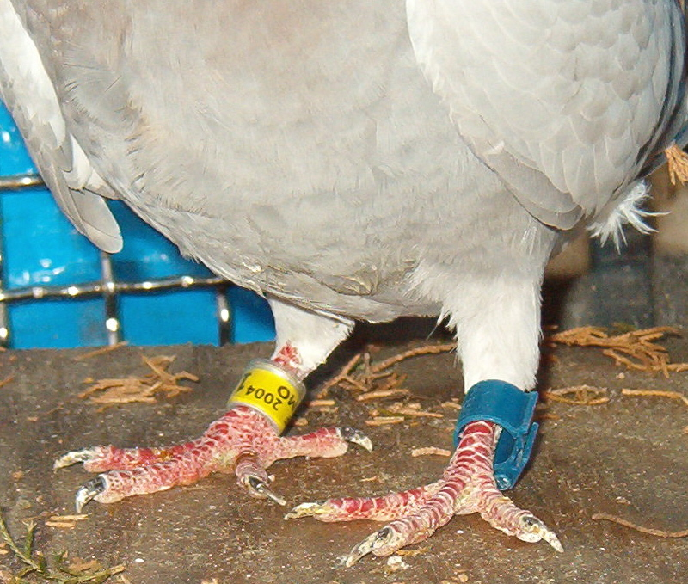
Occasionally wildlife rehabilitators receive birds with metal or plastic bands on their legs. Or, a goose or duck may bear a collar or other marker. Racing or homing pigeons are often received with one or two plastic leg bands on both legs.

Each year more than half a million North American birds are marked with small metal bands placed on their lower leg by licensed banders for the U.S. Fish & Wildlife Service. In spite of the massive number of birds banded annually, less than 5 percent are recaptured or recovered. Hundreds of pigeons are banded by Pigeon Racing Clubs each year. Racing pigeons can get “lost.” When someone reports the band numbers, grateful owners know that the bird is safe, and hopefully, will return home.
The pigeon’s right leg bears an ID band. The left leg carries the race verification

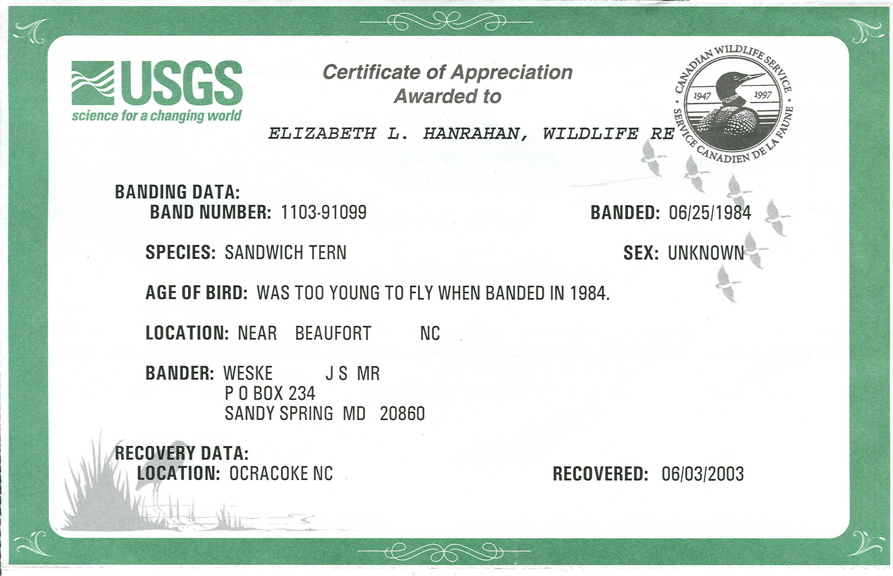
By reporting band numbers, the wildlife rehabilitator can contribute to scientific studies, locate the owner of a valuable sport bird, and thrill the presenter of the bird with a Certificate of Appreciation from the U.S.Geological Survey. All the above provide good public relations for the wildlife rehabilitator and the rehabilitation facility.

USFW Bands

Hundreds of passerines are banded throughout North and South America each year at stations known as MAPS -- Monitoring Avian Productivity and Survival. Specialized banding is done on raptors, seabirds and waterfowl. These birds are banded by federally licensed “cooperators” of the U.S. Fish & Wildlife Service. Each of these bands carries a unique serial number and the abbreviated name and address
(Continued on next page)
of the Fish & Wildlife/ Geological Survey Bird Banding Laboratory in Laurel, Md. When birds are shot by hunters, found dead, recaptured by banders or admitted into wildlife rehabilitation, the numbers should be reported to the laboratory.

In addition to the standard metal Fish & Wildlife leg bands, a variety of markers are used when studies require the identification of individual birds. These banders are also required to have federal banding permits and “auxiliary” marking authorization.

Federal auxiliary markers include plastic cylinders or cone-shaped collars on geese, colored plastic leg bands, radio transmitters or other types of markers. Wildlife rehabilitators are most likely to see the metal leg bands, followed by neck bands or collars on geese. Colored leg bands are rarely used.

Reporting USFW Bands
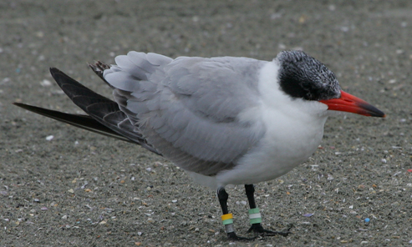
The success of banding and marking efforts depends, in part, on reporting the band. If you receive a bird wearing a Fish & Wildlife band, record the number, the species, age and sex, if known, the condition of the bird, and the precise location where the bird was found. Report the information to the laboratory. The report can be filed online at: http://www.pwrc.usgs.gov/bbl/

If the bird has died, you may remove the band, and mail it, with the information to:
USGS Patuxent Wildlife Research Center
Bird Banding Laboratory
Laurel, MD 20708-4037

If you receive a bird with auxiliary markers, note the same information and include a description of the habitat in which it was found, the specific numbers, colors, and position of the additional markers. This information will be forwarded to the researcher who originally marked the bird.
A Caspian tern carries both USFW metal bands (bottom right leg) and a selection of auxiliary bands.

In all cases, you will receive a Certificate of Appreciation from the U.S. Geological Survey. The certificate lists the locality and date where the bird was banded, if auxiliary markers were present, and a short summary of the research project. You may also request that a certificate be sent to the person who brought the bird to rehabilitation.

Pigeon Bands

It is not unusual for a wildlife rehabilitator to be presented with a banded pigeon. These are usually racing pigeons that have been blown off course during a racing pigeon club event.

It is easy to locate the owner and return the bird after a day or so of “R&R.” Because the cost of these birds ranges from hundreds of dollars to several thousand dollars, owners are grateful to anyone who reunites them with their lost pigeons.

(Continued on next page)

To return the pigeon, record the band number on the admission form. Then go to the internet and either Google “banded pigeons” or go to the website for the International Federation of American Homing Pigeon Fanciers at www.ifpigeon.com. Here you will find information and contacts for all racing pigeons. You also will find information on care and proper release.

You can easily read the band number that will tell you the origin of the bird. For example, a number might be IF-1964-SMO-2004. This series of letters and numbers would be interpreted as:
IF = International Federation
1964 = the serial number identifying that bird
SM0 = local Pigeon Club code within the organization
- = the year the pigeon was born.

You may then call or write the owner of the bird and make arrangements to have the owner pick it up or release the bird and allow it to fly home. Be sure to notify the owner when the bird is released.
In the case above, the pigeon was from Naples, Fla. It entered its 10th race of the 2005 season on April 16. It was to fly from Naples, Fla. to Atlanta, Ga. A low-pressure area and storms blew it off course. It was recovered on Ocracoke Island on Monday, April 18th.

Book Corner

By Brenda Hiles

“The Geese of Beaver Bog”
By Bernd Heinrich
HarperCollins
202 pages
$24.95

In the summer of 1998, biologist Bernd Heinrich became a foster parent to a gosling he named Peep. Peep lived on the lawn of Heinrich's house in Maine, following him and his family like she would her own. Heinrich devised strategies to escape Peep's attention. He'd throw cracked corn on the lawn and slip out the back door. But Peep soon became wise and followed him.
The first time she saw him get in his pick up truck, she followed, flying behind him along the road to town. "Perhaps to Peep I had entered something akin to a flock; I had disappeared into something big, mobile, and noisy," Heinrich writes. "And so she had followed." A week later, Peep leaves Heinrich, presumably to join one of the noisy, honking formations of Canada geese heading south for the winter.

So begins the adventures of "The Geese of Beaver Bog."

Bernd Heinrich, whose earlier books include "Winter World," and "Ravens in Winter," makes readers see the world afresh. The common place and the mundane become wondrous. Heinrich's enthusiasm and joy in the natural world is infectious.

Peep returns to Heinrich's cabin two years later. Through her, he meets the other Canada geese that inhabit Beaver Bog: Pop, Jane, Harry and the Sedge pair. He tells them apart by the slight variations in their white face patches. We're also introduced to other denizens of the pond: red-wing black birds, grackles, cedar waxwings and the frogs that provide a soundtrack to spring's arrival.

(Continued on next page)

The book is an entrée to the private lives of Canada geese. It has all the elements of a good drama: love, jealousy, infidelity, and a fight for survival. The incubation period of eggs, which might not be expected to lend itself to drama, is filled with suspense: Will the eggs survive? Will Peep know how to be a mother? Will Pop be able to protect Peep and the goslings? Stay tuned.

Heinrich also makes a few discoveries about geese that have yet to be explained. Within two days of hatching, the parents lead the goslings on a two-mile trip to another pond. To reach the pond, they have to walk through a half-mile of forest filled with predators, over a hill through hayfields and across a road.

Heinrich also observed geese adopting additional young into their brood when the biological parents took off with another group of geese. He theorizes that the extra youngsters act as a predator shield by providing more eyes to see danger.

Heinrich chose to conduct a field study of the geese rather than an all-out scientific investigation. A scientific investigation would have involved catching the geese, banding them, videotaping the nests and spending a good deal of time begging for money to finance the study "I lived and recorded it willy-nilly as it occurred without expectation, and hopefully without bias, to try to reveal patterns and isolate them from the imagined," he writes.

Heinrich also sees no problem in naming the geese rather than assigning them numbers. Most scientists avoid the practice in order to keep from attributing human characteristics to their subjects. Heinrich doesn't believe science suffers from the bond between researcher and animal. The danger for scientists is not the love of the animal, he writes, but the love of a theory under investigation. By giving the geese names, he brings their stories to life, they become members of the family, to be worried over and cherished.

Shortly after reading "The Geese of Beaver Bog," I had the pleasure of seeing several geese at a park in Greensboro. I was delighted to notice the variations in their white face patches. As Heinrich noted, they were all slightly different. I watched as one goose nodded his head up and down and pointed across the parking lot to a pond. "I want to go!" he was saying, just as Pop had encouraged Peep to leave Heinrich's yard for the bog. A few seconds later, the geese were crossing the parking lot, heading to the water.

That gorgeous opossum cage

Any one interested in the 24 x 24 wire cage that was given away at the WRNC Symposium raffle?
Contact Bob Kiger at 910-867-7559.
The pickup price per cage will be $50.00.

Directories

State membership directories will be mailed this month; if you arranged for a printed directory and haven’t received yours by the end of the month please contact Carla Johnson at cmjohnso@wfubmc.edu.

WRNC
2542 Weymoth Rd
Winston-Salem, NC 27103

ADDRESS CORRECTION REQUESTED

