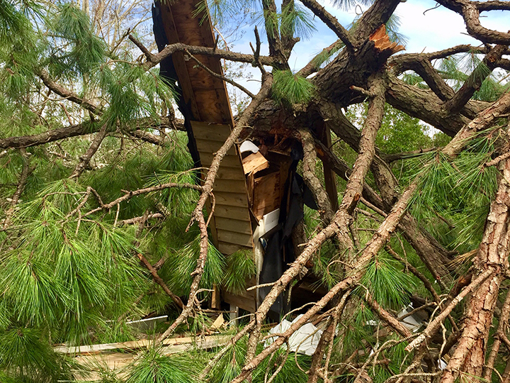
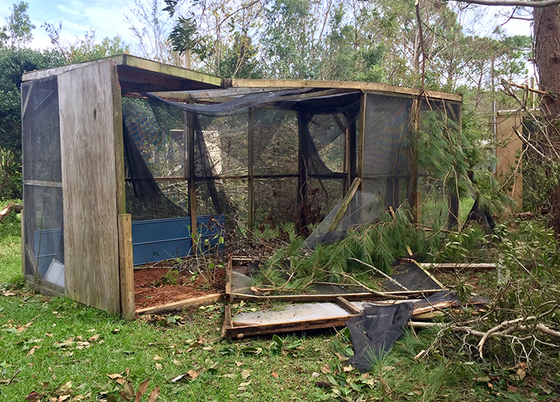
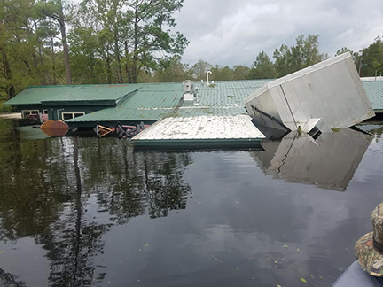
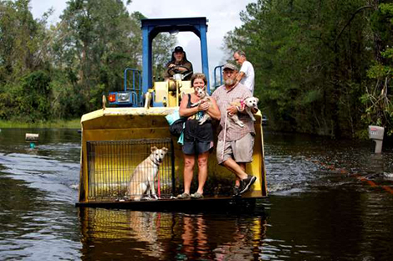
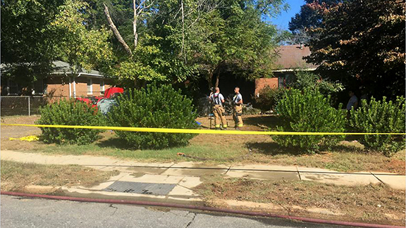
CHECK YOUR ELIGIBILITY STATUS AND CONTACT THE EMERG/DISASTER FUND PROGRAM COORDINATOR:

lbergmanx@gmail.com

